**A survey to explore the reasons for non-renewal of membership in Canterbury and District u3a 2025**

**Abstract**

Aim: To explore the reasons why members of Canterbury and District u3a did not renew (or considered not renewing) their membership in 2025. This was prompted by the observation that a considerable number seemed to fall into this category for 2024.

Method: An online questionnaire survey, based on findings of similar studies run by other u3as.

Findings: Figures obtained from the membership team revealed that 192 (16%) of c.1200 members failed to renew by an extended cut-off date and 49 (25.5%) of these responded to the online questionnaire survey. The most common reason for joining the u3a was interest in a particular course and the most common reason for non-renewal was being too busy/having other commitments (41%), followed by finding travelling to venues difficult (18%), health issues and courses not being available (both 14%) and moving away (12%). A minority reported other reasons (1 to 3 respondents each). Free text comments which respondents were invited to make were overwhelmingly positive of the u3a in question. Possible implications of these findings are discussed.

**Background/justification**

Canterbury u3a is a part of the UK-wide network of more than a thousand local groups. The mission of u3a is to bring members together in the spirit of ‘learning for fun’. Canterbury u3a now has over 1,000 members, participating in a wide range of activities including courses in languages, history, literature, science, music, art, philosophy, social science and more informal groups sharing a common interest, such as gardening, bridge and cinema.

The Canterbury u3a membership is valid for a year, after which members need to renew their membership which involves a small yearly fee. All members are sent a renewal notice via email a month before the renewal date. Renewal can then be made online. It has been noted by the u3a chair and committee in a recent AGM and report that a significant number of members had not renewed their membership and it was suggested that the research group might explore what the reasons for this might be.

**Literature review**

We decided that it would be useful, as a starting point, to determine if similar work had been undertaken before. Although each u3a is unique in character, meaning that any previous studies would not be generalisable, evidence from findings and/or research methods might help inform our own approach.

We identified four potential sources of evidence, and a search of these was allocated to different members of the group:

* Anecdotal evidence (from informal conversations or the experience of group members).
* Letters appearing in ‘u3a matters’, the organisation’s magazine, published five times a year, on related topics.
* Articles uploaded to the national u3a research database.
* Relevant papers in academic journals.

Anecdotal evidence

Suggestions from conversations and the group’s experience included:

* Difficulties with joining/rejoining after a lapse, especially online.
* Difficulties finding way round the website.
* Poor access to venues, especially bus services to the monthly meeting at SMB.
* Courses being full and having to wade through the prospectus to find any still available.

This is likely to be the least representative source of evidence, so these issues may only have been reported by one or two people, therefore may not be representative of the membership. The first two are probably applicable mostly (but not exclusively) to those not confident about dealing with electronic communication and, in most cases, experience suggests can be easily resolved with support, which is available from u3a officers or colleagues. The website itself is in the process of being updated, which may address these problems. In addition the u3a hosts joining days where information and advice is available and, for some communication purposes, is able to provide alternative postal information.

Venue booking is constrained by available facilities, cost, timing and numbers attending, as well as the preference for central venues that are likely to be more accessible than remote ones.

Some popular courses do tend to attract early maximum booking numbers. This may be because the course is more suitable for small numbers or because members tend to join in successive years. Additional groups for a particular topic would require additional group leaders.

Letters in ‘u3a matters’

These are only available from 2022 on the screen reader. Six examples were found, all relating to an original question from a member finding it difficult to persuade her husband to join u3a. Five responses were printed, three from women, two from men. Although they deal with how to attract and retain members, rather than preventing them from renewing, some relevant themes are worth mentioning. These are broadly related to two issues: the nature of the courses/interest group on offer and/or the social context of the u3a.

Comments referred to topics not being appealing to men. The original contributor wrote:

‘*None of the interest groups in our u3a appeal to him, and he says he has nothing in common with the other members. It’s true that many of the groups in our u3a are quite “academic” – and he is a very practical man*…’

Some of the responses appeared to concur, suggesting the husband looked out for something along the lines of ‘Men’s Sheds’ (<https://menssheds.org.uk/find-a-shed/> ) or a ‘repair shop’ which is more practical. Another male agreed:

‘*A man needs a shed: it is somewhere that he can go to be alone on his own property without being ‘in the way’ or ‘making a mess’*’.

However others only partially agreed. Another (male) respondent wrote about needing some time enjoying pastimes alone, but also that he considered himself academic:

‘*I consider myself relatively academic, and I’m never happier than when I have my head stuck in a pile of books or am visiting a museum by myself and not wondering whether a companion is getting bored’*.

These latter two comments also relate to the second theme, that of the social milieu. The original letter writer mentioned that her husband was ‘very shy’, while one of the responding wives reported that her husband found it difficult to fit in:

‘*He found it hard to mix with strangers. We both joined u3a, but I only joined to try and get my husband involved. He started going to meetings on his own but nobody spoke to him*…’

The writer who considered himself academic went on to ascribe his issue with groups to his introvert nature:

‘*As an introvert male in my 60s, I know that my wife (also 60s and very extrovert) gets frustrated that I only belong to a couple of interest groups. Personally, I’m very happy with my own company and get frustrated myself when told I ought to be more sociable*!’

The suggestions for addressing these issues can be summarised as attracting membership through a process, starting with identifying what interests the individual and with finding smaller groups. The next stage is to suggest setting up a group around the individual’s interest if one doesn’t already exist, firstly with a co-leader, then on his own:

‘*He likes board games and we set up a Rummikub group at home for just four people. Only women came but he made a connection with them, and one lady encouraged him to join a walking group. He now walks with men and women and talks to them all. He goes to mahjong and we both go to the gardening club. It has certainly given him lots to look forward to and he is much happier’*.

‘*Classical music was our shared leisure interest so we ran a classical music group for a few years together. Then we ran a humour group and eventually my husband set up a film society in our local village*’.

‘*he may have other interests or hobbies that he can share with both men and women, such as an art group, sport, history or garden trips, for example. The seed has to be sown in such a way that it becomes his idea or his decision’*.

This snapshot of what attracts and fails to attract members, and, by implication, members’ continuation to enjoy u3a, may not apply to the wider u3a, but may be borne in mind as the rest of the evidence sources are interrogated.

Reports uploaded to the national u3a research database

This proved to be the most useful source, with 9 items identified. Although there were others listed, they did not provide a link to a report, therefore were of little value. Most of the articles reported surveys of a local u3a and were either u3a led or run in collaboration with a university, often with a particular focus. They represented 5 individual u3as, as one (Merton u3a) had 4 items, the remaining report being a national survey report.

Topics included broad titles such as ‘membership surveys’, ‘exploring social inclusivity’, ‘men and u3a’, ‘new members’ survey’, ‘survey of attendance at meetings’ and ‘non-renewal survey’ and dates ranged from 2013 to 2022, most dating from around 2014-15. The national survey predated these, in 2009.

Methods included semi-structured interviews, focus groups, online surveys, paper-based mailed surveys, consultations and telephone interviews. Few reported data analysis procedures, with a couple mentioning the use of an Excel spreadsheet and employing simple statistical calculations, with qualitative data subjected to thematic analysis. None mentioned ethical approval or informed consent.

Findings depended on the initial focus, with the broad membership surveys focusing largely on demographic data, particularly the female:male ratio. These consistently found a preponderance of females in u3as with a ratio of around 75%:25%. Merton’s ‘men and u3a’ survey reported that men prefer talks and visits with less commitment involved. However, in their non-renewal survey (the project most closely aligning with ours) no respondents, male or female, reported this to be a deciding factor in renewal.

Of tangential interest, factors attracting people to join a u3a were recommendations by friends/word of mouth or seeing a leaflet in a library, with a smaller number learning about the organisation from the internet or a retirement course. Reasons for joining (and presumably renewing) were to gain knowledge/learning, making new friends, to join a particular course/interest group. Deterrents included lack of knowledge of u3a, the organisation’s name (particularly with its connotation of ‘university’ and ‘third age’), finding groups fully subscribed, inability to find courses of interest, having other commitments and size of group. A number of suggestions for changes were reported in some surveys. For full details, see Table 1.

Relevant papers in academic journals

A search was made on Google Scholar using ‘u3a’ as a keyword. Although a surprising number of papers resulted, most related to the experiences or benefits of u3a membership, rather than exploring why members join or leave. Three papers of some relevance were extracted, only one of which was UK based (the others originated from Australia and Lebanon). Topics were gender issues (again), inclusivity and motivation to study, with methods covering interviews, surveys and focus groups. Findings were not dissimilar to those noted in our other sources. Barriers outlined included health, transport, the organisational name, location, failure to understand the remit of u3as, the nature of courses on offer and social class. The female:male ratio once again arose, with one author commenting on the ‘feminisation’ of u3a. Reasons for studying with u3a were gaining information, meeting people and financial accessibility. For full details see Table 2.

**Table 1: Related lit from national u3a research database**

|  |  |  |  |  |  |
| --- | --- | --- | --- | --- | --- |
| **ID/u3a** | **u3a led/partner** | **Title/topic/date** | **Method** | **Relevant findings** | **Comments** |
| 129 Hartlepool u3a | Collaborative study/Newcastle university partner | Exploring social inclusivity in u3a | Semi-structured interviews + focus groups. N=60 | Barriers included lack of knowledge of u3a, organisational name & location (‘middle class myths’) | See TAM 3, p19  See Patterson et al (2016) on Drive |
| 127 Furness u3a | u3a led | Membership survey 2014 | Online survey (SurveyMonkey)  Single or multiple choice questions (n=183) | 75%f;25%m  76% respondents found u3a through friends.  49% attracted by wide range of activities & groups. Most a member 4+ years. For 65-68% enhanced interests & improved social life | PPT on Drive  Researchers rec:  Recruit more men  Encourage younger people to join  More publicity |
| 139 Lancaster & Morecambe u3a | u3a led | Membership survey 2015 | Online and paper-based survey (n=449) | Feeling current recruitment by word of mouth worked well. Most members 3+ years. 53% found groups full, 57% found groups at wrong time. | Report on Drive |
| 163 Merton u3a | u3a led with advice from 2 universities | Men and u3a 2013 | Lit review, basic demographics of membership, consultations across other u3as. | Under-representation of men for many reasons (f:m=3:1). Most join through word of mouth. Failure to collect data on reasons for joining or leaving. Men prefer talks & visits with less commitment. | Report on Drive  Authors suggest need to collect more data on membership e.g. reasons for joining/leaving via application forms, survey or from group leaders. |
| 448 National | u3a led | National survey 2009 | Random sample n=2,819 selected via u3a chairs. Survey + ‘other approaches’ | F:m=71:29  S.E had higher | Report on Drive  S.E had higher % of pop. over retirement age as u3a members |
| 510 Merton u3a | u3a led | Membership survey 2013 | Anonymous questionnaire mailed with renewal forms, n=863, covering demographics, how heard of u3a, reasons for joining, pref learning methods. Imported to Excel spreadsheet. Chi square to test for differences in groups (gender, age ranges) Qual data and thematic analysis | 422 of 863 returned (49%). 63% heard about u3a from friends, 18% library, <1% retirement course. Reasons for joining: gain knowledge 69%, mix with stimulating people 58%, make new friends 44%. Preferred method of learning: informally in reg group 76%. Suggestions for improvement: satisfied 45%, suggs for activity/courses 16% | Report on Drive  Parts of Q might be useful for our study, not sure we need demographics - is there a concern for representativeness?  Canterbury 2021 census data available for comparison. |
| 511 Merton u3a | u3a led | New members survey 2014 | New members (in last 6 mo) invited to lunch, then repeated after a further 6 mo. N=149). Invited to complete a questionnaire adapted from member survey.  Transferred to Excel sheet for cross-tab. QL data analysed using thematic analysis. | Response rates of 38% (first survey) and 28% (second survey). 78% f. Sources of info on u3a: friends 69%, library 19% internet 10%. Reasons for joining: to gain knowledge 68%, Mix with stimulating people 62%, make new friends 60%, also specific classes. Most pop learning method: attending talks76%, informal regular groups 67%, few chose online. Generally positive comments. Some found no places left on courses, sugg introductory lunch or initial meetings. | Report on Drive |
| 512 Merton u3a | u3a led | Non-renewal survey 2014-15 | Reminder by email plus in newsletter. Remainder phoned (details passed on from membership sec. to a member with research experience). | 136 of 849 had not renewed after one reminder (inc. 9 partnership memberships). 126 contacted by phone. Most common reasons for non-renewal were busy, health problems or moving away. 15 rejoined in response to call. No difference between m & f. Of those identifying problems related to u3a (n=16), most common issue was inability to find activities of interest or oversubscribed groups. Just over one third indicated they might renew. | Report on Drive  No info on data protection/ethical approval.  Authors suggested room for introduction of more groups to meet needs. Cited Islington u3a which found that sending reminders boosted response rates. |
| 1079 Worcester u3a | U3a led | Survey of attendance at meetings 2022 | Questionnaire to all 819 members in light of falling attendance. 2 reminders. Response rate 33%. meetings (currently fortnightly) | 44% found meetings mostly enjoyable 53% mixed but worth going to. 56% preferred monthly Most popular topics were local interest, history and travel. Least popular was entertainment and story telling. 56% found out details via newsletter, 38% via email. 58% attended as interested in the talk, 37% for social reasons. Reasons for non-attendance: 45% other commitments, 38% lack of interest, 11% avoid large groups, 9% don’t know anyone. | On Drive  Authors suggest newer members more interested in small groups rather than large meetings. Suggest could make meetings more welcoming for new members. |

**Table 2: Studies via Google Scholar**

|  |  |  |  |  |
| --- | --- | --- | --- | --- |
| **Author/date/Journal**  **details** | **Research question or focus** | **Research methods, sample details e.g. ages, numbers, setting** | **Main findings of**  **relevance** | **Comments e.g. how relevant/similar, strengths, weaknesses** |
| Patterson et al 2016  Ageing & Society 36, 1580-1603 | Exploring inclusivity in u3a | One u3a in N.E. England  Semi structured interviews x 60  Focus groups x 8  Age 50+ | Barriers outlined including health, transport, org name, location, didn’t understand remit of u3as, social class, gender (‘feminisation’ of u3a) | Interesting comments on co-production of research with university. Limitations: small scale, specific locality. |
| Williamson, 2000 Educational Gerontology 26, 1, 49-66 | Gender issues in older adults’ learning – u3a experiences | One case study  in Sydney, Australia  Survey n=190  Interviews x 56  Documentary research | 75% u3a members are women | Has situation changed since 2000? Are there enough activities for men? Not UK based. Specific locality. |
| Hachem, 2023  Studies in the Education of Adults 55, 1, 82-100 | Motivation of u3a members to learn | Zoom interviews with 11 participants in Lebanon. | Reasons motivating learning in u3a: contextual (e.g. retirement), intrinsic (e.g. wish to remain up to date) educational (e.g. affiliation to a university), practical (e.g. proximity)  Reasons for leaving include: boredom, courses not of interest, courses of interest not offered. | Not UK, but u3a an international organisation. |

Summary

Our four sources of evidence provide triangulated data supporting a number of recurrent issues around what attracts people to remain as members of u3a and, by implication, renew their membership. These include a provision for learning alongside a social acceptance. The few deterrents/reasons for non-renewal alongside the general satisfaction illustrated in survey findings include fully subscribed courses, finding no courses of interest, having other commitments, forgetting to renew, not feeling welcome, issues with access (geographical and online) and lack of understanding of the u3a remit. Data collection methods were largely self-report measures based on questionnaire surveys, interviews and focus group discussions.

Most of these studies and reports are based on very small samples and relate to specific u3as, and are therefore not amenable to generalisation. Nevertheless, the evidence provides us with a starting point for exploring the issue of non-renewal of membership in Canterbury and District u3a.

**Research aim**

To explore the reasons why members of Canterbury and District u3a did not renew (or considered not renewing) their membership in 2025.

**Plan of investigation**

Overall design

We decided to undertake a descriptive, cross-sectional survey via an electronic questionnaire to address the research aim. Contact with members was made via the membership team, who held the membership database, as for reasons of confidentiality we were unable to contact members directly. In addition, we were aware that those who had not renewed by the cut-off date would have their details deleted in compliance with General Data Protection Regulations (GDPR) guidelines (<https://gdpr-info.eu/>). This meant that, as we were unable to ask directly why members had not renewed, since they could no longer be contacted, we decided to change our focus to exploring why members were considering not renewing.

Sample

The above constraints meant that we needed to use a convenience sample comprising those members who volunteered to respond to the questionnaire. We anticipated that numbers would be limited, since members intending not to renew might be less likely to respond to the invitation from the membership team, or, indeed, emails from the u3a as an organisation itself.

Data collection procedure

We decided to conduct our data collection to coincide with the annual renewal reminder email, sent to all members for the year March 2025-March 2026. A link to the questionnaire invited members who were considering not renewing their membership to respond, and to give reasons why this may be the case. A reminder was sent out by the membership team ahead of the cut-off date (14th March) to the whole membership. As they were not required to delete non-responders from the database immediately, a further reminder was sent, post cut-off, only to those failing to respond.

The items for the questionnaire were informed by a combination of questions from the four sources of evidence as outlined in the literature review. To maximise the depth and breadth of the information we hoped to obtain from data collection, the design of the questionnaire consisted of both fixed choice responses to questions and free text opportunities for participants to expand on their reasons for their responses, or to add additional information (see appendix).

An electronic version of the form was created using Google Forms and pilot tested on members of the wider u3a research group. All those responding found it easy to navigate, while further minor changes were made in response to comments. This included deleting one of the fixed choice options which referred to forgetting to renew, as at the initial stage the cut-off renewal date had not been reached and we were still exploring future plans. For the final reminder, we retained the same format of the questionnaire, assuming that any who had forgotten would add this to the free-text ‘other’ option.

Data analysis

Data analysis consisted of two approaches covering both the fixed choice responses and the free text comments. The first utilised simple descriptive statistics in the form of number counts, while the second themed the content into key areas. Braun and Clarke (2006) describe a method which we drew upon to identify and report patterns (themes) and to capture issues that helped to inform the research question.

Data presentation included tabulation and bar charts as visual representations of quantitative (fixed choice) findings, while qualitative (free text) data were presented in narrative form. Both these analytical methods identified issues that were influencing participants’ engagement with u3a, but also enabled us to identify some of the reasons affecting their decisions.

Timescale

|  |  |  |  |  |  |  |  |  |  |  |  |  |  |  |  |  |
| --- | --- | --- | --- | --- | --- | --- | --- | --- | --- | --- | --- | --- | --- | --- | --- | --- |
|  | January 2025 | | | | February 2025 | | | | March 2025 | | | | April 2025 | | | |
| Survey launch |  |  |  |  |  |  |  |  |  |  |  |  |  |  |  |  |
| Survey close |  |  |  |  |  |  |  |  |  |  |  |  |  |  |  |  |
| Analysis |  |  |  |  |  |  |  |  |  |  |  |  |  |  |  |  |
| Report |  |  |  |  |  |  |  |  |  |  |  |  |  |  |  |  |

**Ethics**

As the survey findings would not be generalisable, being limited to Canterbury u3a and therefore not considered to fall within the usual definition of research, we did not consider that our work would require external ethical review. However, we were prepared to be advised on this by the committee and refer to our link university for further advice if thought necessary. The survey remained anonymous, as no personal data were collected. Respondents were required to confirm that they had read an information sheet and signed a mandatory consent form which was integrated into the questionnaire. All data were stored on a secure shared Google Drive, accessible to the u3a research group only.

**Findings**

The overall response rate to the questionnaire sent to the total membership of c.1200 was 25.5% (n=49) of those not renewing (n=192). This consisted of those initially responding with intent not to renew (n=23) and those not renewing but responding after two reminders by an extended date (4th April). The number not renewing by the second cut-off date was 192 (about 16% of the membership).

We present the findings below following the sequence of the research questions (see appendix). NB Not all respondents replied to each question, so some responses are <49.

Length of membership of Canterbury and District u3a

The 48 responses were divided approximately evenly across the four options (1 year or less, 1+ to 5 years, 5+ to 10 years and 10+ years:

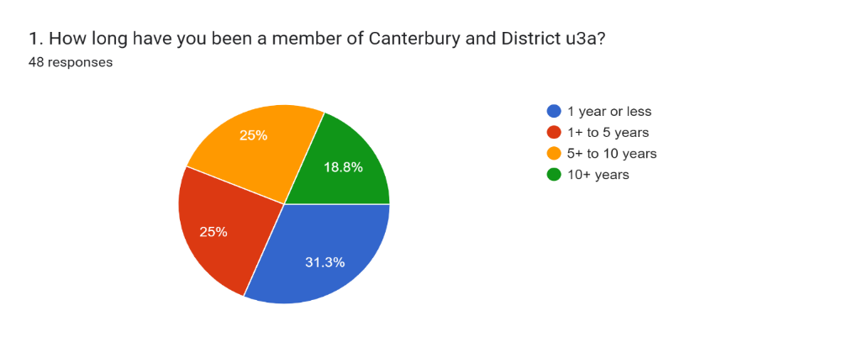

Reasons for joining u3a

Of the fixed choice options, the main reason for joining u3a was an interest in a particular course or activity, with gaining knowledge also popular. The 49 respondents contributed to a total of 89 reasons (the instructions were to tick all options that apply). Two individuals added their own reasons which were being helpful to society and running their own courses.

2. What were your reasons for joining?

49 responses

Reasons for not renewing

We provided 9 options for responding to this question, of which the most popular was being too busy or having other commitments (n=20, 40.8%). Travelling to the venue attracted 9 responses (18.4%) with the rest scoring 7 or under. In addition, 15 individuals offered their own reasons. In total we received 68 reasons:

3. Please tell us why you have decided not to renew your membership of Canterbury u3a this year, or are considering not renewing. Tick all that apply.

49 responses

Additional free-text responses included moving from the area (n=6), and one each of the following:

* On own without a car
* Have enjoyed courses in the past but now nothing of interest
* Too orientated towards women, lectures and courses
* Change of circumstances
* Now an active member of Saxon Shore u3a [a neighbouring u3a]
* Getting too old
* Member passed away
* Joined because I thought a friend would enjoy the course; I joined she didn’t

Expectations of Canterbury and District u3a

Over 85% of responses indicated that expectations were met:

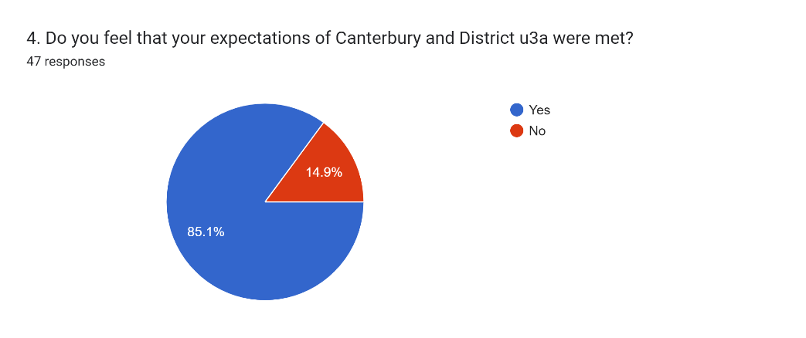

Question 5 invited respondents to enlarge on their responses to this question and 16 individuals did so. A number of these re-iterated responses already made to question 3 or were included in the fixed-choice options. Another 4 commented positively but stated they now belonged to another u3a. Other positive comments included enjoying the course they attended, finding the u3a very welcoming, an enormous range/variety of interests/courses, or too many, having enjoyed courses in the past. Less positive comments included enrolling on a course which wasn’t a success, expectations met but having now ‘done’ those, no suitable language course, few courses being ‘hands on’, too much art, music and dance, not enough history.

Age categories of respondents

Nearly 50% of respondents were in the 71-80 age bracket, with around 20% each in the 61-70 and 81+ groups. Only 6.1% were in the 51-60 group.

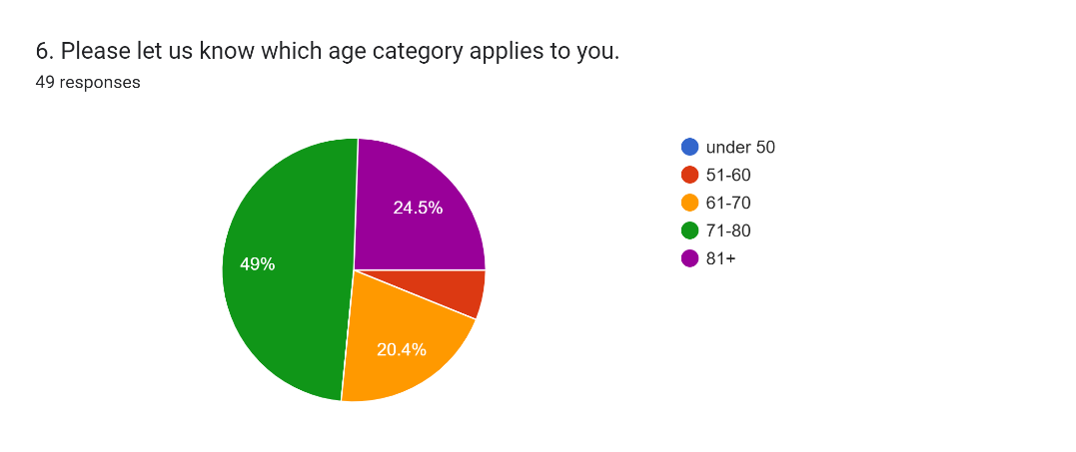

Awareness of other u3a activities

Over 85% of respondents were aware of the u3a interest groups, monthly meetings, outings and holidays, with the remainder aware of some of these activities. None of these latter individuals felt that would have made a difference to their decision whether or not to renew.

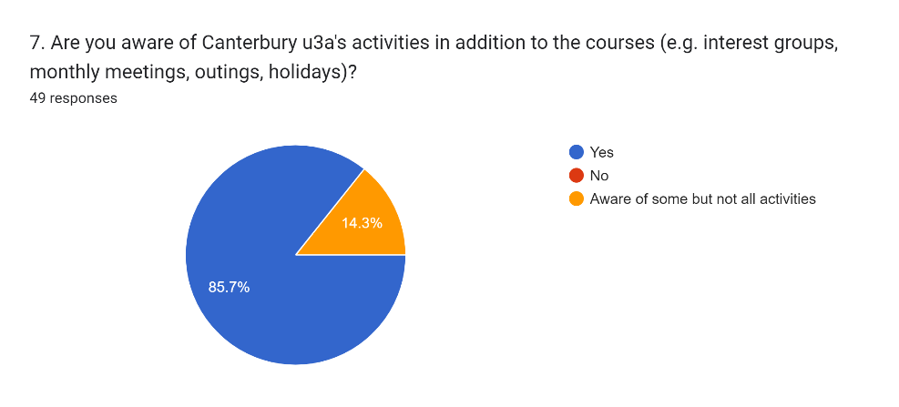

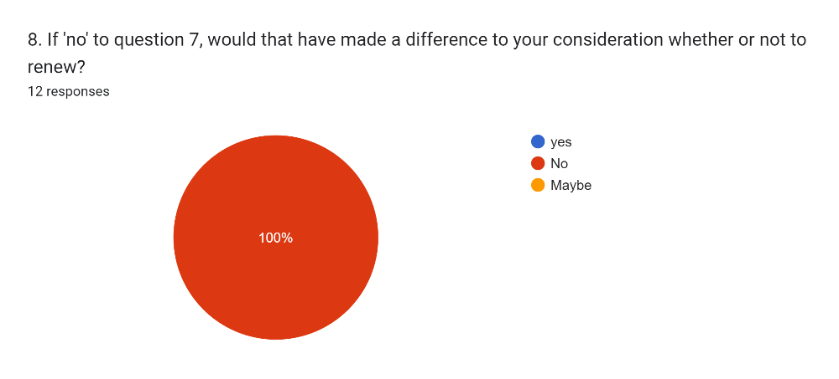

Other comments

There were 21 responses to the invitation to make further comments. Most of these were very positive, offering thanks or expressing enjoyment and appreciation to predicate any other response, which often reiterated the responses to question 3. These are reported in full here (minus one which repeated information and another which reported the death of a member):

*‘I think the people organising U3A work hard and do an amazing job which I appreciate but as I have already stated I feel it doesn’t cater for my situation. I don’t want my comments to be seen as a criticism.’*

*‘Very grateful for my membership, and also for the wonderful ZOOM yoga sessions during Covid, had hoped these classes could have continued . Valued my membership, and withdrawing with thanks for the experience of being a member.*

*‘Thank you all for your hard work. You have a great variety of courses & interests’*

*‘Carry on with the good work Canterbury and thank you.’*

*‘I had a lovely 11ish years with the Research group. Sorry to leave. But I am about to join my (now) local U3A in Witney, West Oxfordshire.’*

*‘Thanks for the friendship and interests I have enjoyed sharing for many years.’*

*‘I have very much enjoyed being a member of U3A, well organised and friendly. I have enlarged my friendship circle as I have met some lovely people. My husband has been diagnosed with Alzheimer's which I think says it all Warm Wishes to all of you, [name].’*

*‘Thanks for giving me some lovely friends and interesting courses.’*

*‘I am nearly 91 and can no longer drive. Walking is limited. I have enjoyed being a member for over 40 years but must finish now. I thank you for my membership.’*

*‘It was very welcoming thanks.’*

*‘Thanks to ALL committee members/course providers etc., etc over the years. Am renewing anyway to show support. Best wishes [name]’*

*‘It’s a good U3A - I have been a member of two other U3A’s and Canterbury is the equal of both - the other two are Cambridge and London.’*

Of the remainder, comments generally referred to either lack of time due to other commitments or to the nature of the courses:

*‘I have attended mainly the art courses and have not had interest in others at the moment.’*

*‘Only a couple of courses I was interested in and either on a waiting list or I can’t get to.’*

*‘I'm also a member of Saxon Shore. I found I did/do more activities with them sadly leaving insufficient time for Canterbury U3A.’*

*‘I find it difficult committing to courses long into the future, and they fill up quickly making it impractical to join later on.’*

*‘Need to have courses/lectures and holidays which interest men!’*

*‘I initially joined very quickly after moving from London to Faversham and before fully exploring activities closer to home. When I did they gradually took over and were more accessible.’*

**Discussion**

It is worth considering the findings from this survey by looking at the reasons for non-renewal in the light of responses to the other questions. Firstly, it is noteworthy that the non-renewals were distributed fairly evenly across all four survey age groups, meaning that, while nearly one-third of members only remained for a year or less, some 70% have stayed from between 1 and 10 years. It would be interesting to compare the turnover with the number of new joiners through the year, to gauge how stable the overall membership of Canterbury u3a is.

Reasons given for joining u3a are supported by our literature review, suggesting that these are a feature of other u3as. This is perhaps not surprising, since they reflect the learning ethos of u3a in the context of social groupings. Moreover they are to some extent paralleled in the reasons for leaving, notably around the inability to access courses and the positive comments in the free text responses around friendship and enjoyment, which will be missed due to outside reasons.

Reasons for leaving particularly mirror the findings from the other u3a surveys which most closely resemble ours. For example Merton u3a found the main reason for members not renewing was being too busy. Anecdotally, this appears to be a current experience of third agers, and a finding which Peter Laslett (one of the UK u3a founders) would not be surprised to learn of; he saw the conventional ‘retirement years’ being transformed in his time as a period of engagement and development.

A number of comments were received from both the 85% who encouragingly felt their expectations of Canterbury u3a were met and the 15% who felt the opposite. Some of these repeated the responses to question 3 but it perhaps of significance in this context of expectations that 4 members had joined other (usually closer) u3as, implying a positive experience of the u3a movement in general.

In terms of the age make-up of the sample, nearly half of respondents fell within the 71-80 age bracket, with very few under 60 (presumably partly due to the changing retirement age) and 20% in the 61-70 bracket. The fact that nearly one quarter of members responding to the survey were in their 80s may account for the 26+% who gave reasons of difficulty with travel and access as reasons for non-renewal. This may beg the question of whether there is any way this could be addressed for any still wishing otherwise to continue (providing lifts, more courses on Zoom for example).

Finally, it is heartening to know that most respondents were aware of all the activities provided by Canterbury u3a, and that, even if they were unaware, this would not have made a difference to their decision not to renew membership. Also pleasing were the positive comments invited at the end of the questionnaire. One area not previously touched on was the comment that there is a need for courses/lectures and holidays which interest men. The so-called ‘feminisation’ of u3a is a topic which has featured in much of the literature we explored, for example, Merton u3a conducted a survey specifically around the issue of the male:female ratio, theorising that this may be a reason why members fail to renew (in the event, this was not mentioned by any respondents, male or female to their non-renewal survey). The gender ratio is, however, a well-accepted feature of u3as in general; findings from a Third Age Trust (2009) report found a 74%f:26%m difference, which seems to be not unusual. The question of suitable courses, however, is arguably a different one, since tastes vary across both genders. The need for more courses also implies the need for more course leaders to facilitate these, which can be problematical.

**Recommendations for Canterbury u3a and further research**

Overall, this survey paints a very positive picture in terms of satisfaction with how Canterbury and District u3a is run. The greatest number of reasons for non-renewal concern issues outwith the remit of the u3a (outside commitments, moving away, health issues etc.). There are, however, a few issues which invite further attention.

* Consideration might be given to how to enhance the inclusion of those finding difficulty accessing activities and courses (for example having more Zoom/Teams offerings, prompting car-sharing).
* It might be worth exploring in greater depth the reason for non-renewal of the 30+% of those who fail to renew after one year, since it is possible that they account for the small percentage of those whose expectations were not met.
* It was interesting that one respondent commented on the lack of opportunities for men. However this was an isolated comment, which echoes the findings of Merton u3a, so it is difficult to know whether this should be pursued, given the associated need for extra course provision.
* We feel it could be useful to repeat the survey on an annual basis, but with a less detailed questionnaire, in order to document trends in membership.
* We suggest that the report be available to all members via the national u3a research database.

**Methodological limitations**

This was a very limited survey with a small sample and is not intended to be generalisable beyond Canterbury and District u3a. In addition the sample was self-selecting, so not representative of the total number not renewing and there may be a bias towards those expressing positive experiences and those more proficient in dealing with IT. Nevertheless, this report does provide a snapshot of some of the reasons for non-renewal of membership and we therefore present it as providing some guide to decision-making within our u3a.

**Conclusion**

We have investigated the reasons why members of Canterbury u3a consider not renewing their membership, along with associated demographics and data which we consider may help to explain our findings. Overall, the reasons given by the 16% who failed to renew were largely accounted for by circumstances outside the u3a’s remit and are in keeping with what we know about other u3as. There appear to be limited implications for action resulting from this.

**Acknowledgements**

The research group would like to acknowledge the support of the membership team in facilitating the circulation of the survey to members and particularly to all those who responded to our questionnaire and enabled this exercise to take place.

**References**

Braun, V. & Clarke, V. (2006) Using thematic analysis in psychology. Qualitative Research in Psychology 3, 77-101.

Hachem, H (2023) Ask them why: older learners’ motivational reasons for learning at a university for the third age. Studies in the Education of Adults 55, 1, 82-100

Patterson, R. et al. (2016) Exploring social inclusivity within University of the Third Age (U3A): a model of collaborative research. Ageing & Society 36, 2016, 1580-1603.

Third Age Trust (2009) Survey of u3a members. Unpublished.

Williamson, A (2000) Gender issues in older adults' participation in learning: viewpoints and experiences of learners in the university of the third age (u3a). Studies in the Education of Adults 55, 1, 82-100.

**Appendix: Non-renewal survey questionnaire draft v.6 rev 7/1/25**

INTRODUCTION

Members of u3a Canterbury and District’s research group are conducting a survey of members who are considering not renewing their membership this year. You are invited to take part in this survey by clicking the link below. The survey will only take a few minutes to complete and will help the committee of Canterbury u3a to plan for future provision. Please respond by 20th March.

[link added]

PARTICIPANT INFORMATION

**Name of study**: Canterbury and District u3a non-renewal survey

**What will taking part involve**? The study will involve answering a 5-minute questionnaire which aims to capture information on why members have decided not to renew this year.

**What will happen to the information I provide?** Data will be analysed by study team members, with findings forming a report which will be considered by the Canterbury and District u3a committee. The questionnaire is anonymous and data will be stored for 7 years by the study team and committee, after which it will be reviewed. All data and personal information relating to the survey will be stored securely in accordance with the General Data Protection Regulations (GDPR) and the data protection policies of the Third Age Trust. Participants will not be identifiable in reports relating to the study. If you have any questions please contact one of the below study team members.

(contact details provided)

CONSENT FORM (mandatory)

I confirm that I have read and understood the Participant Information for the study and

have had the opportunity to ask questions

I understand that my participation is completely voluntary

I understand that the data I provide will be stored securely and will not be shared with any third party or organisation

I agree to take part in the study

1.How long have you been a member of Canterbury and District u3a?

1 year or less

1+ to 5 years

5+ to 10 years

10+ years

2.What were the reasons you decided to join? (tick all that apply)

Interest in a particular course or activities

To gain knowledge

To make friends

To mix with stimulating people

Other (please state) _________________________

3.Please tell us why you are considering not renewing your u3a membership this year. Tick all that apply and add other reasons and information if applicable:

I am too busy/have other commitments

Health issues (your own or another’s)

The courses/activities offered were not of interest to me

The course(s) I was interested in was/were over-subscribed

Travelling to venues was difficult for me

The venues were not accessible for me

I have problems with the website

Booking and paying for courses was an issue

I did not feel welcome

Diversity related issues

Other (please state or enlarge on any answers in the space provided) (allow plenty of space) __________________________________

4. Do you feel your expectations of Canterbury and District u3a were met? Y/N

5. Please feel free to enlarge on your answer to Q.4 if needed ________________________________

6. Please let us know which age category applies to you:

Under 50

50-59

60-69

70-79

80-89

90+

7. Are you aware of Canterbury u3a’s activities in addition to the courses (e.g.interest groups, outings, holidays, monthly meetings)? Y/N/aware of some but not all.

8. If no to Q.7 would that have made a difference to your consideration whether or not to renew? Y/N

9. Please add any other comments you have relating to your u3a membership_______________________________________________

Thank you for your response. A report on the survey will be available on Canterbury & District u3a website.